Program Catalogue | 2025-2026 | دليل البرنامج الدراسي

University of Information Technology and Communications (UoITC)  جامعة تكنولوجيا المعلومات والاتصالات  College of Medical Informatics  كلية المعلوماتية الطبية الحيوية  Department of Intelligent Medical Systems  قسم الانظمة الطبية الذكية | 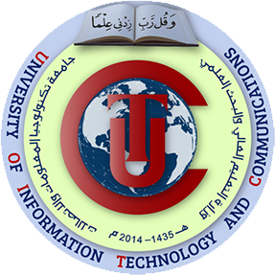  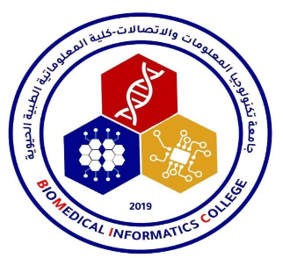  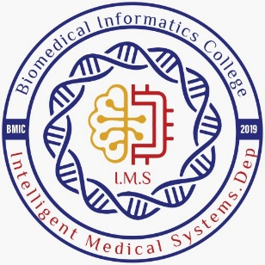
Third Cycle – Bachelor’s Degree (B.Sc.) - Science in Intelligent Medical Systems
بكالوريوس – علوم في الأنظمة الطبية الذكية

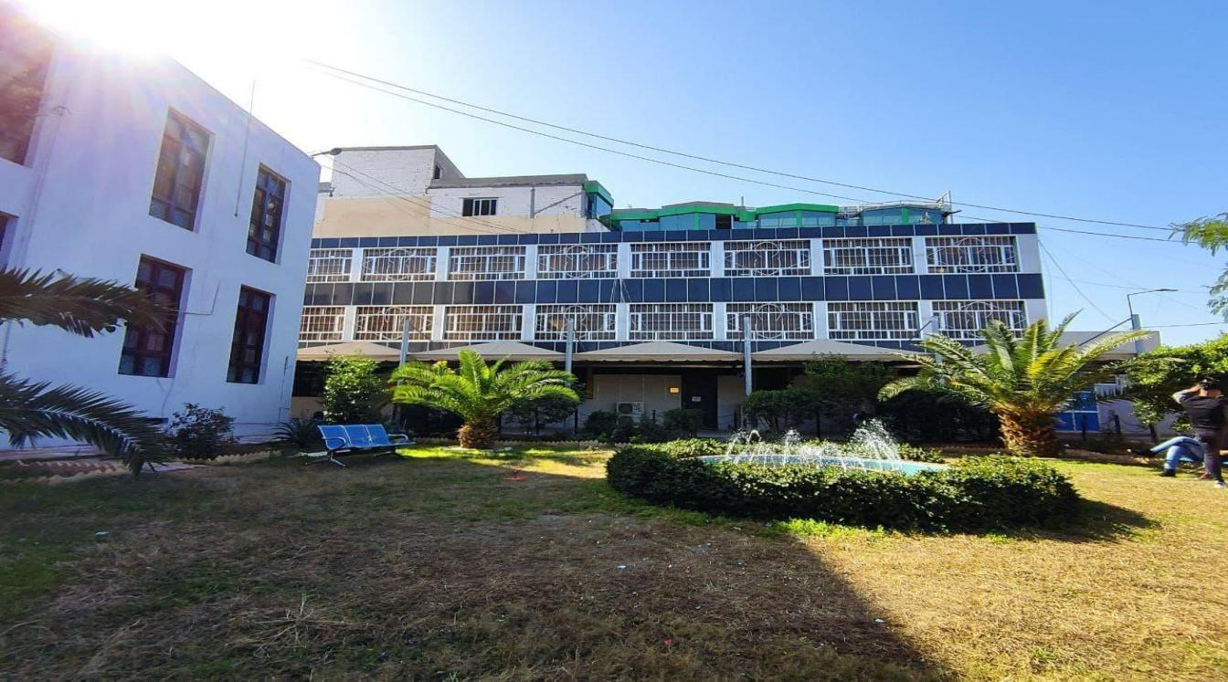

Table of Contents | جدول المحتويات

- Mission & Vision Statement | | بيان المهمة والرؤية
- Program Specification | | مواصفات البرنامج
- Program (Objectives) Goals | | أهداف البرنامج
- Program Student learning outcomes | | مخرجات تعلم الطالب
- Academic Staff | | الهيئة التدريسية
- Credits, Grading and GPA | | الاعتمادات والدرجات والمعدل التراكمي
- Modules | | المواد الدراسية
- Contact | | اتصال

1. Mission & Vision Statement

Vision Statement
The Intelligent Medical Systems Department is aspired to be a distinguished section of the local and international level in the field of supporting and developing health systems and developing scientific research and meeting the needs of government institutions and the labor market with the aim of improving the quality of the health care.
Leadership and excellence in developing an educational and research program in the field of biomedical informatics to meet the requirements of governmental institutions and the labor market at the local and international levels.

Mission Statement
The Department of Intelligent Medical Systems is a new specialty in Iraqi universities that links the specialty of information technology and medical information systems in order to prepare a distinguished graduate possess the skills needed to keep pace with advances in information technology and mastering them to medical and biological uses and who are qualified for competing in the labor market at the local and international levels.
Providing academic and qualitative programs to prepare graduates with high skills in the field of bioinformatics to be able to contribute in solving the problems of society of an interlaced nature between information technology and biomedical.

2. Program Specification
Program code | BSc-IMS | ECTS | 240
Duration | 4 level, 8 Semesters | Method of Attendance | Full Time

Intelligent medical systems, a field that is used in the development of smart medical technologies and systems, and the ability to keep pace with the rapid developments in modern digital medical technologies. Studying in this department we strive to enable students to design and innovate under the close mentorship of our world-class faculty. Our students learn by doing from their very first class, and quickly transition to authentic Technology projects with real-world corporate, government and nonprofit partners.
3. Program Goals
The Department of Intelligent Medical Systems seeks to prepare a distinguished graduate with the ability to:
- Using and developing intelligent medical technologies and systems, and the ability to keep pace with the rapid developments in modern digital medical technologies, and competition in the labor market.
- Assigning workers in the health field, including surgeons, analysts, and disease specialists, with systems that support their daily work and serve the achievement of results for medical diagnoses and analyzes in less time and with higher accuracy.
- Collecting, discovering and analyzing medical data and knowing how to use it to serve scientific research and assist various agencies in achieving integrated health care.
- Strengthening cooperation with interested sectors inside and outside Iraq.
- Contributing to scientific research with various research ideas to assist to support and enhance the medical diagnosis systems.
- Upgrading the student’s personality by cultivating moral and human values and the national spirit and teaching them the skills of the art of leadership and searching for methods of solving problems and commitment to quality and professional behavior.
- Providing students with the basic skills that enable them to deal with the environment and conditions of future work effectively, the ability to innovate and diversify, and to find important solutions to the problems they face accurately and quickly, given the importance of these two elements for the success of any medical diagnosis, whether it is manual or digital.
- Creating an art of dialogue and constructive competition between students with each other, which will have a significant and distinguished reflection on professional work by promoting the spirit of teamwork and constructive professionalism.
4. Student Learning Outcomes
1- Intelligent medical systems aim to improve the quality of interventional health care in a way that depends on data collection, analysis, understanding and then employing smart systems that support specialists in this field, which will contribute to reducing medical errors resulting from the hard daily work of doctors and relying on self-assessment, which is not devoid of these errors.
2- The Department of Intelligent Medical Systems works to ensure that the academic program's outputs are based on principles and knowledge from a variety of research areas including artificial intelligence, medical image processing, data analysis, computer vision, bio-imaging, and medicine.
3- Committed to the ultimate goal of creating benefit for patients and medical staff, we aim to develop a holistic concept that spans three important topics: visualization and interpretation of data and real-time assistance and connectivity through a cycle of continuous learning: new spectral imaging technologies are enabled by machine learning deep learning as safe, reliable, and real-time imaging modalities during surgical interventions.
4- When interpreting perceived data in the context of available knowledge, our department specifically addresses common obstacles to clinical translation such as data scarcity, interpretability, and handling uncertainty.
5- With such cooperation with partners in the health and medical field, we can take advantage of these aforementioned methods to develop diagnostic assistance systems and digital analysis using various algorithms and tools in the field of information technology.
6- Transforming medical systems into a medical application machine available to all to facilitate the process of first diagnosis or self-examination by the patients themselves or by doctors who do not have sufficient experience to help them as a preliminary examination or preliminary diagnosis prepared for consultation by specialized centers.
7- One of the most important pillars that the department cares about is working to achieve high accuracy of digital examinations and analyzes, as well as reliable verification of the results of artificial intelligence algorithms and other tools that have been added to design and model various medical systems, applications and sites necessary to perform predictions, classifications of diseases and clinical diagnoses.
5. Academic Staff
- Zainab N. Yousif |PH.D. in Computer Sciences |Lecturer
Email: dr.zainab.n.yousif@uoitc.edu.iq
Mobile no.: 07901740618
- Muneera Abed Hmdi |PH.D. in Computer Science| Lecturer
Email: dr.muneera.alsaedi@uoitc.edu.iq
Mobile no.: 07715443193
- Ahmed Wadi Shehab |PH.D. in Mathematics Science |Lecturer
Email: ahmed.shiahb@uoitc.edu.iq
Mobile no.: 07706857209
- Mazin Hussein Abdullah| PH.D in Structural Engineering |Lecturer
Email: dr.mazin.hussein@uoitc.edu.iq
Mobile no.: 07700824636
- Dunia Hamid Hameed| Ph.D. in Computer Science |Lecturer
Email: dr.dunia.hamid@uoitc.edu.iq
Mobile no.: 07801881607
- Atyaf Sami Noori |Ph.D. in Information Technology| Lecturer
Email: dr.atyaf.sami@uoitc.edu.iq
Mobile no.: 07803324711
- Ahmed Majid Taha |Ph.D. in Artificial Intelligence|Lecturer
Email: dr.ahmed_majid@uoitc.edu.iq
Mobile no.: 0770 269 3966
- Mustafa waleed zaheer |Ph.D. in Accounting |Lecturer
Email: mustafa92_waleed@yahoo.com
Mobile no.: 07704356009
- Hiba Adil Mhdi | PH.D. in Arabic Language |Lecturer
Email: hiba.adil-bic@uoitc.edu.iq
Mobile no.: 07702596409

- Waleed Khalid Hussein | Ph.D. in Computer Science | Lecturer
Email: dr.waleed.khalid@uoitc.edu.iq
Mobile no.: 07901343639

- Ghaith Jaafar Mohammed | PhD in Computer Engineering | Lecturer
Email: dr.ghaith.jaafar@uoitc.edu.iq
Mobile no.: 07749741222
- Roaa Safi Abed Allah |MSc in Computer Engineering | Assistant lecturer
Email:rouaa.safi@uoitc.edu.com
Mobile no: 07853456162
- Moatasim Amer Mohammed |MSc in Physics |Assistant lecturer
Email: moatasim.amer@uoitc.edu.iq
Mobile no.: 07901779304

- Ali Hikmat Abbas |M.Sc in Chemistry | Assistant lecturer
Email: ali.hikmat-bic@uoitc.edu.iq
Mobile no.: 07706552044
- Dalya Samer Al-Delaimy| MSc. in Information Technology | lecturer
Email: daliadelaimy86@uoitc.edu.iq
Mobile no.: 07717222070
- Safanah Zaid Ahmed | MSc Bioinformatic and Computational Biology |Assistant Lecturer
Email: Safanah.bayati-bic@uoitc.edu.iq
Mobile no.: 07838243183
- Fatima Qassim Abdul-Majeed | MSc. in Physic | Assistant Lecturer
Email: fatima.kasim-bic@uoitc.edu.iq
Mobile no.: 07724019097
- Aseel Abbood Jawad |MSc. in Mathematics Science | Assistant Lecturer
Email: aseel.abood-bic@uoitc.edu.iq
Mobile no.: 07714166845
- Zaid Ali Saeed |MSc. in Computer Communication Engineering | Assistant lecturer
Email: zaid.ali-bmic@uoitc.edu.iq
Mobile no.: 07705334814
- Zainab Mustafa Ridha Alameen |MSc. in cyber security information management | Assistant Lecturer
Email: zainab.mustafa@uoitc.edu.iq
Mobile no.: 0771 895 5982
- Rana Abdulhameed Hadi | MSc. in Mathematics Science | Assistant Lecturer
Email: rana.abdulhameed@uoitc.iq
Mobile no:07901651403
- Shireen Nazar qasim | Msc. Genetic engineering and Biotechnology |Assistant Lecturer
Email: shireen.nazar@uoitc.edu.iq
Mobile No. :07728711177
- Ansam Ali Abdulameer |MSc. in computer science | assistant lecturer
Email: ansam.ali@uoitc.edu.iq
Mobile No :07711339112
- Haneen Farooq Abdulhameed | MSc. in Biotechnology | Assistant lecturer
Email: haneen.farooq@uoitc.edu.iq
Mobile no.: 07700747131

- Saja Ali Ahmed Al_jumor |MSc. in Biotechnology | Assistant Lecturer
Email: Saja.ali@uoitc.edu.iq
Mobile no.: 07712272651
- Sarah Manea Abdullah | MSc. In Banking Finance |Assistant Lecturer
Email: sara. manea@uoitc.edu.iq
Mobile no: 07727179244

- Mohammad Qassim|MSc. in computer science | Assistant Lecturer
Email: mohammad.qassim2002@uoitc.edu.iq
Mobile No:07818658581
- Hiba Mohammed Wajeh Majeed | MSc. in computer science | Assistant Lecturer
Email: hibawajih@uoitc.edu.iq
Mobile No :07802775099
- Noor Sabah Abbas | MSc. in computer engineering | Assistant Lecturer
Email: noorsabah.ab@gmail.com
Mobile No: 07712947555
- Duaa Jaffer Salh| MSc. in Media| Assistant Lecturer
Email: duaa.jaafar@uoitc.edu.iq
Mobile No: 07813613606

- Eman Dawood Aljubouri| MSc. in computer engineering | Assistant Lecturer
Email: emanaljubouri@uoitc.edu.iq
Mobile No: 07715438052

- Hayder Talib Jawad| MSc. In Computer Engineering | Assistant Lecturer
Email: mr.haider.talib@uoitc.edu.iq
Mobile No: 07822655197

6. Credits, Grading and GPA

Credit System
The University of Information Technology and Communications adheres to the Bologna Process, implementing the European Credit Transfer System (ECTS).
The total number of ECTS required for the degree program is 240, with 30 ECTS earned per semester. Each ECTS corresponds to 25 hours of student workload, encompassing both structured and unstructured activities.

Grading
Prior to evaluation, results are categorized into two groups: pass and fail. Consequently, the results are independent of the students who did not pass a course. The grading system is outlined as follows:
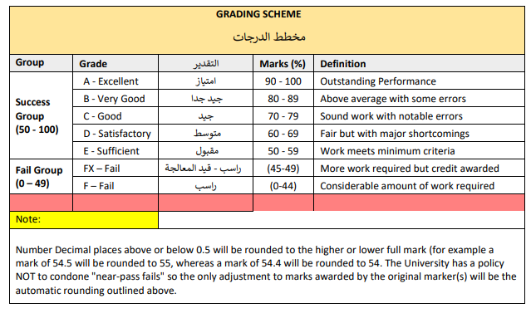

Calculation of the Cumulative Grade Point Average (CGPA)
- The CGPA is determined by summing the product of each module score and its corresponding ECTS, then dividing the total by the program's overall ECTS.
For a 4-year B.Sc. degree, the formula is as follows:
CGPA = [ (1st module score x ECTS) + (2nd module score x ECTS) + ……] / 240
7. Curriculum/Modules
Semester 1: 30 ECTS: 1 ECTS = 25hrs
Module Code | Module Name in English | SSWL | USSWL | SWL | ECTS | Module Type | Pre-request
ITC300000 | Biology | 63 | 87 | 150 | 6 | C | /
ITC300011 | Computer Programming I | 63 | 87 | 150 | 6 | B | /
ITC300020 | Computer Fundamentals | 63 | 37 | 100 | 4 | B | /
ITC310000 | Mathematics | 63 | 87 | 150 | 6 | B | /
ITC310010 | Introduction to Medical Informatics | 63 | 87 | 150 | 6 | C | /
ITC000000 | Democracy and Human Rights | 33 | 17 | 50 | 2 | S | /
Total |  | 378 | 372 | 750 | 30.00

Semester 2: 30 ECTS: 1 ECTS = 25hrs
Module Code | Module Name in English | SSWL | USSWL | SWL | ECTS | Module Type | Pre-request
ITC300012 | Computer Programming II | 63 | 87 | 150 | 6.00 | B | ITC300011
ITC310020 | General Anatomy and Physiology | 63 | 62 | 125 | 5.00 | C | ITC300000
ITC310030 | Molecular Biology | 63 | 62 | 125 | 5.00 | C | ITC300000
ITC310040 | Logic Design | 63 | 62 | 125 | 5.00 | B | /
ITC310050 | Medical Devices and Terminology | 63 | 62 | 125 | 5.00 | C | ITC310010
ITC000031 | English Language I | 33 | 17 | 50 | 2.00 | S | /
ITC000041 | Arabic Language I | 33 | 17 | 50 | 2.00 | S | /
Total |  | 381 | 369 | 750 | 30.00

Semester 3: 30 ECTS: 1 ECTS = 25hrs
Module Code | Module Name in English | SSWL | USSWL | SWL | ECTS | Module Type | Pre-request
ITC300030 | Object Oriented Programming | 63 | 87 | 150 | 6.00 | C | ITC300011
ITC300040 | Data Structures | 63 | 87 | 150 | 6.00 | C | ITC300011
ITC310060 | Discrete Mathematics | 33 | 42 | 75 | 3.00 | B | ITC310000
ITC310070 | Human Diseases for the Health Professions | 63 | 87 | 150 | 6.00 | C | ITC310050
ITC310080 | Operating Systems | 63 | 112 | 175 | 7.00 | B | ITC300020
ITC000010 | Crimes of the baath regime in Iraq | 33 | 17 | 50 | 2.00 | S | /
Total |  | 318 | 432 | 750 | 30.00

Semester 4: 30 ECTS: 1 ECTS = 25hrs
Module Code | Module Name in English | SSWL | USSWL | SWL | ECTS | Module Type | Pre-request
ITC310090 | Biochemistry | 63 | 87 | 150 | 6.00 | C | ITC300011
ITC310100 | Bioinformatics | 63 | 87 | 150 | 6.00 | C | ITC310010
ITC310110 | Database Systems | 63 | 87 | 150 | 6.00 | B | /
ITC310120 | Statistics and Probability | 63 | 87 | 150 | 6.00 | B | ITC310000
ITC310130 | Data Science Ethics | 33 | 17 | 50 | 2.00 | S | /
ITC000032 | English Language II | 33 | 17 | 50 | 2.00 | S | ITC000031
ITC000042 | Arabic Language II | 33 | 17 | 50 | 2.00 | S | ITC000041
Total |  | 351 | 399 | 750 | 30.00

Semester 5: 30 ECTS: 1 ECTS = 25hrs
Module Code | Module Name in English | SSWL | USSWL | SWL | ECTS | Module Type | Pre-request
ITC300050 | Artificial Intelligence | 63 | 62 | 125 | 5.00 | C | ITC300011
ITC310140 | Image Processing | 63 | 62 | 125 | 5.00 | C | ITC310000
ITC310150 | Geographical Information Systems | 63 | 62 | 125 | 5.00 | C | /
ITC310160 | Applications Development | 63 | 62 | 125 | 5.00 | C | ITC310110
ITC310170 | Software Engineering | 63 | 62 | 125 | 5.00 | B | /
ITC310180 | Computer Networks | 63 | 62 | 125 | 5.00 | C | ITC300020
Total |  | 378 | 372 | 750 | 30.00

Semester 6: 30 ECTS: 1 ECTS = 25hrs
Module Code | Module Name in English | SSWL | USSWL | SWL | ECTS | Module Type | Pre-request
ITC300060 | Web Development | 63 | 62 | 125 | 5.00 | B | ITC310160
ITC300070 | Machine Learning | 63 | 62 | 125 | 5.00 | C | ITC300050
ITC310190 | Computer Vision | 63 | 62 | 125 | 5.00 | C | ITC310140
ITC310200 | Embedded Systems | 63 | 62 | 125 | 5.00 | C | ITC310080
ITC310210 | Mobile Applications | 63 | 62 | 125 | 5.00 | C | ITC310160
ITC310220 | Wireless Sensor Networks | 63 | 62 | 125 | 5.00 | C | ITC310180
Total |  | 378 | 372 | 750 | 30.00

Semester 7: 30 ECTS: 1 ECTS = 25hrs
Module Code | Module Name in English | SSWL | USSWL | SWL | ECTS | Module Type | Pre-request
ITC300080 | Cloud Computing | 63 | 62 | 125 | 5.00 | E | ITC300060
ITC300090 | Data Mining | 63 | 62 | 125 | 5.00 | C | ITC300070
ITC310230 | Electronic Health Records | 63 | 62 | 125 | 5.00 | C | ITC310110
ITC310240 | Deep Learning | 63 | 62 | 125 | 5.00 | C | ITC300070
ITC310250 | Simulation and Modeling in Medical Applications | 63 | 62 | 125 | 5.00 | E | ITC310180
ITC300101 | Final Project I | 32 | 93 | 125 | 5.00 | C | /
Total |  | 347 | 403 | 750 | 30.0

Semester 8: 30 ECTS: 1 ECTS = 25hrs
Module Code | Module Name in English | SSWL | USSWL | SWL | ECTS | Module Type | Pre-request
ITC310260 | Big Data Analytics | 63 | 62 | 125 | 5.00 | E | ITC300080
ITC310270 | Information Security | 63 | 62 | 125 | 5.00 | C | ITC310000
ITC310280 | Health Care Systems Administration | 63 | 62 | 125 | 5.00 | C | ITC310230
ITC310290 | Human and Computer Interaction | 63 | 62 | 125 | 5.00 | C | ITC310210
ITC310300 | Medical Multimedia | 63 | 62 | 125 | 5.00 | C | ITC310140
ITC300102 | Final Project II | 32 | 93 | 125 | 5.00 | C | ITC300101
Total |  | 347 | 403 | 750 | 30.0

8. Contact
Program Manager:
Zainab N. Al-Qudsy| Ph.D. in Computer Science |Lecturer
Email: dr.zainab.n.yousif@uoitc.edu.iq
Mobile no.: +9647901740618
Program Coordinator:
Roaa Safi Abed Allah |MSc in Computer Engineering | Assistant lecturer
Email:rouaa.safi@uoitc.edu.com
Mobile no: 07853456162

